**MESD Documentation LMS-19-Rollover-Student-to-the-next-level**

**Purpose**

To allow for users to progress through the different levels of education.

**Background**

The MESD LMS will be hosted and housed by the 1Gov 1Citizen platform. This initiative exists to provide services to provide residents of Botswana in a more efficient and effective manner. The LMS will need to allow for learners to progress through the different levels of education.

**How to do it?**

With appropriate privileges navigate to the user profile of the student you want to rollover and click edit.

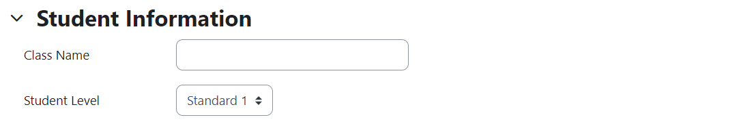

Select from the drop down the new level you want to assign the user.

To do this for a large group of students make use of the upload users functionality. Refer to the bulk import documentation.